|  |  |  |  |  |
| --- | --- | --- | --- | --- |
|  |  | | |  |
|  |  | | |  |
|  | Second Row Seat Position Control  <<Feature>>  (F003517) | | |  |
|  |  | | |  |
| Document Type | **Feature Document (FD)** | | |  |
| Template Version | **6.0b / FFSD 8.0** | | |  |
| SysML Report Template Version | **O (11/12/2019)** | | |  |
| Document ID | **ffst01.10_featuredocument_sysmlreporttemplate** | | |  |
| Document Location |  | | |  |
| Document Owner | **Diana Aguilar (daguil24@ford.com)** | | |  |
| Document Revision | **FD1** | | |  |
| Document Status | **Draft** | | |  |
| Date Issued | **2020-10-27** | | |  |
| Date Revised | **2020-10-27** | | |  |
| Document Classification | GIS1 Item Number: | **27.60/35** | |  |
| GIS2 Classification: | **Confidential** | |
|  | | | | |
|  | | | | |
| Document Approval | | | | |
| Person | Role | | Email Confirmation | Date |
|  |  | |  |  |
|  |  | |  |  |

**Auto-Generated by MagicDraw**

Printed Copies Are Uncontrolled

# Disclaimer

**This document contains Ford Motor Company Confidential information. Disclosure of the information contained in any portion of this document is not permitted without the expressed, written consent of a duly authorized representative of Ford Motor Company, Dearborn, Michigan, U.S.A.**

**Copyright, Ó 2016 Ford Motor Company**

This document contains information developed and accumulated by and for FORD MOTOR COMPANY. As such, it is a proprietary document, which, if disseminated to unauthorized persons, would provide others with restricted information, data, or procedures not otherwise available, exposing the FORD MOTOR COMPANY to potential harm.

Employees and suppliers having custody of this specification or authorized to use it must be cognizant of its proprietary nature and ensure that the information herein is not made available to unauthorized persons.

FORD MOTOR COMPANY reserves the right to protect this work as an unpublished copyrighted work in the event of an inadvertent or deliberate unauthorized publication. FORD MOTOR COMPANY also reserves its rights under copyright laws to protect this work as a published work.

This document or portions thereof shall not be distributed outside FORD MOTOR COMPANY without prior written consent. Refer all questions concerning disclosure to the author(s) or to any duly authorized representative of Ford Motor Company.

# Contents

1.1.2 Decomposition of Functional Safety Requirement 13

Disclaimer 22

Contents 23

2 Introduction 26

2.1 Document Purpose 26

2.2 Document Scope 26

2.3 Document Audience 26

2.3.1 Stakeholder List 26

2.4 Document Organization 26

2.4.1 Document Context 26

2.4.2 Document Structure 27

2.5 Document Conventions 27

2.5.1 Requirements Templates 27

3 Feature Overview 28

3.1 Purpose and Description of Feature 28

3.2 Feature Variants 28

3.2.1 Regions & Markets 29

3.3 Input Requirements 29

3.3.1 Legal Requirements 30

3.3.2 Trustmark Requirements 30

3.3.3 Industry Standards 30

3.3.4 Attribute Requirements 30

3.4 Lessons Learned 30

3.5 Assumptions 31

3.6 References 31

3.6.1 Ford Documents 32

3.6.2 External Documents and Publications 32

3.7 Glossary 33

3.7.1 Parameters / Values 33

4 Feature Context 34

4.1 Feature Context Diagram 34

4.2 List of Influences 34

5 Feature Modeling 36

5.1 Operation Modes and States 36

5.2 Use Cases 38

5.2.1 Use Case Diagram 38

5.2.2 Actors 39

5.2.3 Use Case Descriptions 39

5.3 Driving and Operation Scenarios 43

5.4 Decision Tables 45

6 Feature Requirements 46

6.1 Functional Requirements 46

6.1.1 Error Handling 47

6.2 Non-Functional Requirements 47

6.2.1 Safety 47

6.2.2 Security 47

6.2.3 Reliability 47

6.3 HMI Requirements 47

6.4 Other Requirements 48

6.4.1 Design Requirements 48

6.4.2 Manufacturing Requirements 48

6.4.3 Service Requirements 48

6.4.4 After Sales Requirements 48

6.4.5 Process Requirements 48

6.4.6 Uncategorized Requirements 49

7 Functional Safety 50

7.1 System Behaviors for HARA 50

7.2 Safety Assumptions 50

7.3 Safety Goals 51

7.4 Functional Safety Requirements 53

7.4.1 Safety Goal: 53

7.4.2 Derivation of Functional Safety Requirements on Assumptions 55

7.5 ASIL Decomposition of Functional Safety Requirements 56

8 Architecture 57

8.1 Functional Architecture 57

8.1.1 List of Functions 57

8.2 Logical Architecture 58

8.2.1 Logical Interfaces 59

9 Open Concerns 61

10 Revision History 62

11 Appendix 63

11.1 Definitions 63

11.2 Abbreviations 63

**List of Figures**

Figure 1. 12

Figure 2: 28

Figure 3: - 28

Figure 4: 34

Figure 5: 36

Figure 6: 38

Figure 7:  55

Figure 8: 57

Figure 9: 58

**List of Tables**

Table 1: Features described in this FD 26

Table 2: Feature Variants 29

Table 3: Regions & Markets 29

Table 4: Ford internal Documents 32

Table 5: Ford internal Documents *(not specified in SysML model)* 32

Table 6: External documents and publications 32

Table 7: External documents and publications *(not specified in SysML model)* 33

Table 8: Parameters / Values used in this document *(Not supported by MagicDraw report generation)* 33

Table 9: List of Influences 35

Table 10: Operation Modes and States on 36

Table 11: Transitions between Operation Modes and States on 38

Table 12: List of Actors 39

Table 13: System Behaviors for HARA 50

Table 14: Functional Safety Assumptions 51

Table 15: Functional Safety Goals 53

Table 16: List of Functions 58

Table 17: List of Functions on 58

Table 18: Feature Interactions 59

Table 19: Feature Interactions on 59

Table 20: Open Concerns *(Not supported by MagicDraw report generation)* 61

Table 21: Definitions used in this document 63

Table 22: Abbreviations used in this document 64

# Introduction

## Document Purpose

A Feature Document (FD) document specifies **what** the feature shall do and how it shall behave from customer perspective. It should also provide reasoning and background **why** we have the feature in the vehicle.

The FD also serves as an Item Definition as defined by ISO26262 for those features, which follow the Ford Functional Safety process.

To get more information about the concept of feature, function and component level abstraction refer to the [Ford RE Wiki](http://wiki.ford.com/display/RequirementsEngineering/Requirements+Engineering+for+SW+Enabled+Features). For details on the Ford Functional Safety (ISO26262) process refer to the [Ford Functional Safety Sharepoint](https://pd3.spt.ford.com/sites/GlobalFunctionalSafety/Pages/default.aspx).

## Document Scope

This Feature Document (FD) specifies the following features:

|  |  |  |  |
| --- | --- | --- | --- |
| **Feature ID** | **Feature Name** | **Owner** | **Reference** |
| F003517 | Second Row Seat Position Control  (Program(s): CX747 (GE2 Platform)) | Diana Aguilar (daguil24@ford.com) |  |

Table 1: Features described in this FD

## Document Audience

The FD is written by the feature owner of Diana Aguilar (daguil24@ford.com). All Stakeholders, i.e., all people who have a valid interest in the feature should read and, if possible, review the FD. It needs to be guaranteed, that all stakeholders have access to the currently valid version of the FD.

**#Hint:** The FD template has the IP Classification “Proprietary” by default. IP Classification “Confidential” might be required in some cases, e.g. by Ford Functional Safety.

### Stakeholder List

For the latest list of stakeholder of the feature and their influence refer to <Put VSEM Link here>.

|  |  |  |
| --- | --- | --- |
| **Name** | **Contact** | **System** |
| Todd Beck | TBECK18 | Settings UX Applicable engineer |
| Gail Cheng | GCHENG | SYNC (APIM) |
| Matthew Borrelli | MBORREL4 | SYNC (APIM) |
| Gautam, Paritosh | PGAUTAM1 | ECG |
| Scott Hardiek | SHARDIEK | 2 Row Seat Switches |
| Jonathan Laquinto | JIAQUIN2 | Driver Seat Module (DSM+PSM) |
| Greg Komora | GKOMORA | Driver Seat Module (DSM+PSM) |
| Laura Check | LBUREK | ELECTRONIC MODULES SYNC |
| Pavankumar Surabathula | PSURABAT | ELECTRONIC MODULES SYNC |
| Tumavitch, Jeffrey | JTUMAVIT | PCM |
| David Andree | DANDREE5 | 2 Row Seat Engineer |
| Cartwright, Timothy | TCARTWR8 | VSP |
| Justin Bauer | JBAUER50 | PPP Feature |
| John Moore | JMOOR457 | Stowable Steering Feature |
| Walter Stephens | WSTEPHE1 | Enhance Memory Feature |
| Evangelos Fountis | EFOUTIS | Classic Memory Feature |
| Matt Harkless | MHARKLE1 | Rejuvenate Feature |
| Daniel Limon Balboa | DLIMONBA | Quality Coach |
| Leah Raschid | LRASCHID | CIED |
| Donna Schienke | DSCHIENK | 2nd Row Feature MBSE Modeler |
| Michelle Kinney | MKINNE13 | PMT 5 Leader |
| Spencer Jennings | SJENNI25 | PD Finance Analyst PMT5 |
| Annita Stoffer | ARAMAMU1 | EESE Architecture Engineer |
| Vikram Gokhale | VGOKHALE | Feature Deliverable |

## Document Organization

### Document Context

Refer to the [Specification Structure page](http://wiki.ford.com/display/RequirementsEngineering/Specification+templates) in the [Ford RE Wiki](http://wiki.ford.com/display/RequirementsEngineering/Requirements+Engineering+for+SW+Enabled+Features) to understand how the FD relates to other Ford Requirements Documents and Specifications.

### Document Structure

The structure of this document is explained below:

**Section 1** – Introduction how to use this document including responsibilities and requisite documents. Explains the terminology. Gives a clarification of the definitions, concepts and abbreviations used in the document.

**Section 2** – Feature Description. States briefly the background and the purpose of the feature, feature variants and corresponding regions and markets. Also includes input requirements, assumptions and constraints.

**Section 3** – Feature Context describes all external entities, which have an influence on the feature.

**Section 4** – Feature Modeling. Contains Use Case, Driving Scenarios, State Charts to describe the functional behavior of the feature.

**Section 5** – Safety. Lists System Behaviors and Safety Goals of the feature.

**Section 6** – Feature Requirements. Lists functional and non-functional requirements of the feature.

**Section 7** – Architecture. Shows the coarse architecture, which the feature requirements are deployed to. Describes the elements and the boundary of the feature as well as the decomposition and distribution of associated functions.

**Section 8** – List of Open Concerns

**Section 9** – Document Change History including a list of new or modified requirements. The requirements in this document are tagged, and this section contains different types of tables listing all, new, or changed requirements by their title and page no.

**Section 10** – Appendix

**#Hint:** All sections are mandatory, unless explicitly marked by the tag “#Classification” as “optional” or as applicable e.g. to certain domains like “Functional Safety”.

## Document Conventions

### Requirements Templates

Each requirement, use case or scenario in this specification shall follow the corresponding template given in the document template *Specification_Macros.dotm* at [RE Wiki - Specification Templates](http://wiki.ford.com/display/RequirementsEngineering/Specification+templates?src=contextnavpagetreemode).

#### Identification of requirements

#### Requirements Attributes

The templates provided by *Specification_Macros.dotm* define a list of attributes for each requirement. This helps to classify the requirement. The attributes are explained at [RE Wiki - Requirements Attributes](http://wiki.ford.com/display/RequirementsEngineering/Requirements+Attributes?src=contextnavpagetreemode).

## References

### Ford Documents

List here all Ford internal documents, which are directly related to the feature.

| **Reference** | **Title** | **Doc. ID** | **Document Location** | **Revision** |
| --- | --- | --- | --- | --- |
| Ford GIS Standard | Ford GIS Standard |  |  |  |

Table 4: Ford internal Documents

### External Documents and Publications

The list of external documents could include books, reports and online sources.

**#Hint:** You may refer to [IEEE Citation Reference](http://www.ieee.org/documents/ieeecitationref.pdf) on how to format a reference.

| **Reference** | **Document / Publication** | **Document Location** |
| --- | --- | --- |
| IEEE Std 1012-2004 IEEE Standard for Software Verification and Validation |  |  |
| ISO/IEC 19500-2:2003 | Information technology -- Open Distributed Processing -- Part 2 |  |
| UML Testing Profile (UTP), v1.2 |  |  |
| Wikipedia |  |  |

Table 6: External documents and publications

## Glossary

**#Hint**: Terms, concepts and abbreviations used in the document shall be defined and illustrated here. Note that changes to terms and/or concepts described in this section tend to cause major updates to this document.

The tables below have feature specific definitions and abbreviations. For additional, non-feature specific terms please refer to the [RE Glossary](http://wiki.ford.com/display/RequirementsEngineering/Glossary?src=contextnavpagetreemode)

See Appendix for Definitions and Abbreviations.

### Parameters / Values

| **Name** | **Description** | **Range / Resolution** |
| --- | --- | --- |
|  |  |  |

Table 8: Parameters / Values used in this document *(Not supported by MagicDraw report generation)*

# Feature Overview

## Purpose and Description of Feature

**#Hint:** Some descriptive text to explain the purpose and functionality of the feature.

The Second Row Seat Position Control feature is responsible for the following:

1) Power Pitch/Slide Easy Entry/Exit

2) Second row seat calf rest travel

3) Second row seat fore/aft travel

4) Second row seat recline/incline

5) Second row seat lumbar

## Feature Variants

**#Hint:** Definitions for different variants of the feature (if applicable). Give each variant a descriptive name by which it can be referenced further on in the document. If no variant exists, state “No Feature Variants”.

The Variant Description should give a short informative text which describes the variants of the feature.

|  |  |  |
| --- | --- | --- |
| **Variant Name** | **Variant Description** | **Remarks** |
| **Variant 1** | Variant 1 of the Second Row Seat Position Control feature is responsible for the following:  1) Power Pitch/Slide Easy Entry/Exit  2) Second row seat calf rest travel  3) Second row seat fore/aft travel  4) Second row seat recline/incline |  |
| **Variant 2** | Variant 2 of the Second Row Seat Position Control feature is responsible for the following:  1) Power Pitch/Slide Easy Entry/Exit  2) Second row seat fore/aft travel  3) Second row seat recline/incline  4) Second row seat lumbar |  |

Table 2: Feature Variants

### Regions & Markets

**#Hint:** Description of purpose and functionality of the feature. If there is no variant, give feature name in first column.

|  |  |  |  |  |  |  |
| --- | --- | --- | --- | --- | --- | --- |
| **Market /**  **Region**  Variant Name | **North America** | **South America** | **Europe** | **Middle East/Africa** | **Asia / Pacific** | **China** |
| **Variant 1** | Mandatory | No | No | No | No | Mandatory |
| **Variant 2** | Mandatory | No | No | No | No | Mandatory |

Table 3: Regions & Markets

## Input Requirements

**#Hint:** List all input requirements, which are relevant for the feature. Typically, attribute requirements, legal requirements as well as national and international standards have to be considered.

### Legal Requirements

* : Compliance with FMVSS207
  + The Feature shall comply with FMVSS207.
* : Compliance with FMVSS210
  + The Feature shall comply with FMVSS210.

### Trustmark Requirements

No Trustmark Requirements specified.

### Industry Standards

* : ISO 26262
  + The system shall be developed according to Ford's implementation of Functional Safety.
* : PPSEEE Power Mode
  + The feature shall be identical to the power mode specified for the driver seat module - [FS-MU5T-14C030-AAH].

### Attribute Requirements

* : Comfort Adjustments
  + The vehicle shall allow the user's needs to be met for comfort in the SRS.
* : Ingress/Egress Access
  + The vehicle shall provide enough space between the SRS and the 3rd Row Seat to allow access to the 3rd Row Seat.

## Lessons Learned

**#Hint:** Additional information and lessons learned from previous development or related features. A typical source for Lessons Learned is the FMA Quality History.

**#Functional Safety:** In context of Functional Safety Lessons Learned and similar information will be used to check the completeness of the Functional Safety Goals and assumptions in the Hazard Analysis and Risk Assessment (HARA).

**#Link:** [Ford Functional Safety Sharepoint](https://pd3.spt.ford.com/sites/GlobalFunctionalSafety/Pages/default.aspx)

No lessons learned specified.

## Assumptions

**#Classification**: Optional

**#Hint:** A list of known assumptions concerning the effects of the feature’s behavior on other features or elements (i.e., dependencies) as well as assumptions on the behavior expected by the feature (e.g. known limitations). During the course of the feature development most of those assumptions are typically either converted into actual requirements or discarded at some point – such that this chapter remains mostly empty. For assumptions, which are relevant for the Functional Safety process refer to chapter 7.2 “Safety Assumptions”

No Assumptions specified.

# Feature Context

## Feature Context Diagram

**#Hint:** High level diagram of feature interactions with the environment, people or other feature or other external entities.

**#Link:** [RE Wiki - Context Diagram](http://wiki.ford.com/pages/viewpage.action?pageId=107676234&src=contextnavpagetreemode)

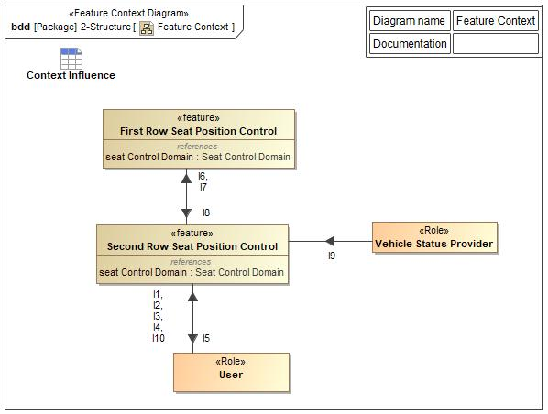

Figure 4: Feature Context

## List of Influences

|  |  |  |
| --- | --- | --- |
| **ID** | **External Entity** | **Influence Description** |
| I1 | User To Second Row Seat Position Control | This information item (IngressEgressRequest) is the input from the "User" to activate the Power Pitch/Slide Easy Entry/Exit functionality in order to ingress/egress the 3rd row seat |
| I2 | User To Second Row Seat Position Control | This information item (ComfortSeatPositionRequest) represents the seat comfort commands that the user will select to move the seats. |
| I3 | User To Second Row Seat Position Control | This information item (IngressEgressAcknowledgement) is the input from the "User" to indicate that the ingress/egress of the 2nd row seat was completed. This will trigger the 2nd row seat to return to a drivable position. |
| I4 | User To Second Row Seat Position Control | This information item (UserTerminatesPitchSlide) in the input from the "User" to terminate the PPSEEE Pitch/Slide Process or the PPSEEE Return Process. |
| I5 | Second Row Seat Position Control To User | This information item (UserNotification) notifies the "User" of any inaction or termination in the PPSEEE Pitch/Slide Process or the PPSEEE Return Process. |
| I6 | Second Row Seat Position Control To First Row Seat Position Control | This information item (FirstRowStimuliRequest) requests that the front seat (that is in front of the second row seat that is being requested to move for easy entry/exit) needs to incline to an upright position (if not already) to make room for second row seat to pitch forward. |
| I7 | Second Row Seat Position Control To First Row Seat Position Control | This information item (FirstRowSeatReset) requests that the first row seat be returned to the "Initial" position. |
| I8 | First Row Seat Position Control To Second Row Seat Position Control | This information item (FrontSeatPosition) from the front seat informs the second row seat of the fore/aft position of the front row seat track, as well as the incline/recline position of the front row seat track. |
| I9 | Vehicle Status Provider To Second Row Seat Position Control | This information item (VehicleStatus) represents the following:  1) Transmission Status: which gear the transmission of the vehicle is in; namely, PARK, DRIVE, NEUTRAL, or REVERSE?  2) Vehicle Speed: What the current speed of the vehicle is in.  3) IgnitionStatus: Which state the ignition of the vehicle is in; namely, OFF, ACC, RUN, or START. |
| I10 | User To Second Row Seat Position Control | This information item (SeatID) represents which seat is being requested to move. |

Table 9: List of Influences

# Feature Modeling

## Operation Modes and States

**#Classification:** Optional (Mandatory for Functional Safety)

**#Link:** [RE Wiki – State Charts](http://wiki.ford.com/display/RequirementsEngineering/State+Charts?src=contextnavpagetreemode)

**#Hint:** State Charts are a popular means to express feature behavior in terms of states and modes. An advantage of this state machine like approach is that consistency can be easily verified.

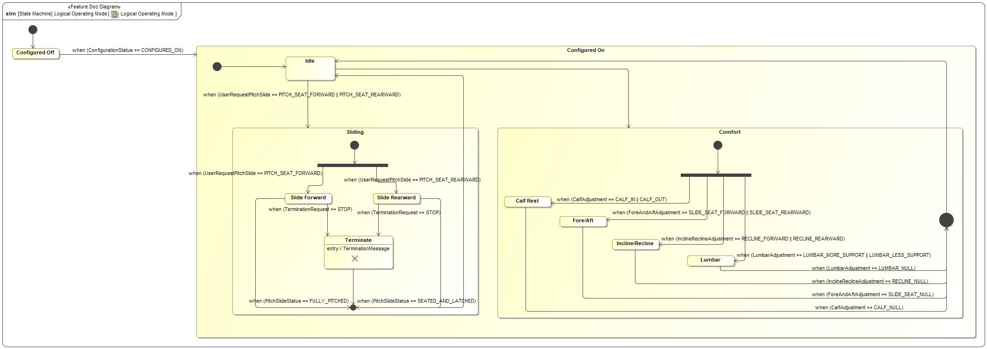

Figure 5: Logical Operating Mode

|  |  |  |
| --- | --- | --- |
| **State** | **Description** | **Requirements Reference** (optional) |
| Calf Rest | The user selects a menu-driven soft switch for adjusting the seat's calf rest angle/position and the calf rest will rotate/adjust position accordingly. |  |
| Comfort |  |  |
| Configured Off |  |  |
| Configured On |  |  |
| Fore/Aft | The user presses/pushes a dedicated button on the seat switch pack for adjusting fore/aft position and the seat moves forward or backward inside the vehicle. |  |
| Idle |  |  |
| Incline/Recline | The user presses/pushes a dedicated button on the seat switch pack for adjusting seat recline angle and the upper half/seat back will adjust its angle relative to the floorboard of the vehicle. |  |
| Lumbar | The user selects a menu-driven soft switch for adjusting the lumbar position and the lumbar setting. |  |
| Slide Forward | The user presses/pushes a dedicated button on the seat for pitching/sliding the requested seat forward. |  |
| Slide Rearward | The user presses/pushes a dedicated button on the seat for pitching/sliding the requested seat rearward. |  |
| Sliding |  |  |
| Terminate | When the pitch/slide terminates, the process stops.  Entry behavior: TerminationMessage |  |

Table 10: Operation Modes and States on Logical Operating Mode

|  |  |  |
| --- | --- | --- |
| **Transition ID** | **Description** | **Requirements Reference**  (optional) |
| T1 |  |  |
| T2 |  |  |
| T3 | Name: PitchComplete |  |
| T4 | Name: PitchRearward |  |
| T5 |  |  |
| T6 |  |  |
| T7 | Name: LumbarAdjustment |  |
| T8 |  |  |
| T9 |  |  |
| T10 |  |  |
| T11 | Name: ForeAftAdjustment |  |
| T12 | Name: CalfAdjustment |  |
| T13 |  |  |
| T14 |  |  |
| T15 |  |  |
| T16 |  |  |
| T17 |  |  |
| T18 | Name: TerminateRearwardPitch |  |
| T19 |  |  |
| T20 |  |  |
| T21 | Name: InclineReclineAdjustment |  |
| T22 | Name: ResetComplete |  |
| T23 | Name: PitchForward |  |
| T24 | Name: TerminateForwardPitch |  |

Table 11: Transitions between Operation Modes and States on Logical Operating Mode

## Use Cases

**#Classification:** Optional

**#Link:** [RE Wiki – Use Cases](http://wiki.ford.com/display/RequirementsEngineering/Use+Cases+Overview?src=contextnavpagetreemodehttp://wiki.ford.com/display/RequirementsEngineering/Use+Cases?src=contextnavpagetreemode)

### Use Case Diagram

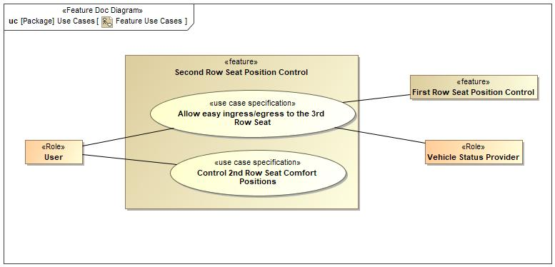

Figure 6: Feature Use Cases

### Actors

| **Actor** | **Description** |
| --- | --- |
| First Row Seat Position Control | The First Row Seat Position Control feature is responsible for the following:  1) First row seat calf rest travel  2) First row seat head rest up/down travel  3) First row seat head rest fore/aft travel  4) First row seat fore/aft travel  5) First row seat up/down travel  6) First row seat cushion tilt  7) First row seat recline/incline  8) First row seat upper thoracic travel  9) First row seat left-thigh extension travel (in/out)  10) First row seat right-thigh extension travel (in/out) |
| User | This will be the person making the request of the Second Row Seat Position Control feature. |
| Vehicle Status Provider | Vehicle Status Provider will provide the following:  1) Transmission Status |

Table 12: List of Actors

### Use Case Descriptions

**#Classification:** Optional

###UC_F_FRS_00001### Allow easy ingress/egress to the 3rd Row Seat

|  |  |  |
| --- | --- | --- |
| **Actors** | Primary | User |
| Secondary | First Row Seat Position Control |
| Secondary | Vehicle Status Provider |
| **Subject** |  | Second Row Seat Position Control |
| **Description** |  | The "Allow easy ingress/egress to the 3rd Row Seat" Use Case is to provide the User easy access to the TRS. The Use Case requests the forward and return (rearward) movement of the requested SRS. |
| **Preconditions** | PreC1 | Vehicle status is idle. |
| **Triggers** | T1 | Receive IngressEgressRequest |
| **Main Flow Description** |  | User requests access to the 3rd row seat. Once the user has access, User requests the seat to go back to original, "Enabled" position. |
| **Main Flow** | M1 | User Requests Access to 3rd Row Seat |
| M2 | Vehicle status is checked by feature. |
| M3 | First Row Seat will begin to move, if necessary |
| M4 | Requested 2nd Row Seat Moves to Allow Access |
| M5 | User accesses 3rd row seat. |
| M6 | User acknowledges completion of task by requesting the originally selected 2nd Row Seat returns to "Enabled" position. |
| M7 | Requested 2nd Row Seat Moves to "Reset" position. |
| M8 | First Row Seat returns to "Initial" position, if necessary. |
| **Alternative Flow Description** |  | N/A |
| **Alternative Flow Steps** | A1 | N/A |
| **Postconditions** | PostC1 | After the SRS has been pitched forward, the SRS is returned to the seated and latched position. |
| PostC2 | The FRS returns to its "Initial" Position. |

###UC_F_FRS_00002### Control 2nd Row Seat Comfort Positions

|  |  |  |
| --- | --- | --- |
| **Actors** | Primary | User |
| **Subject** |  | Second Row Seat Position Control |
| **Description** |  | The "Control 2nd Row Seat Comfort Positions" Use Case is to provide the User to be able to adjust the comfort seats of the requested SRS. |
| **Preconditions** | PreC1 | Second Row Seat of the requested action needs to be in a latched position. |
| PreC2 | Second Row Seat of the requested action shall not be in the minimum/maximum position of the desired movement. |
| **Triggers** | T1 | Receive SeatPositionCommand |
| **Main Flow Description** |  | User requests seat comfort positions. |
| **Main Flow** | M1 | User requests a 2nd row seat to move to a desired comfort position. |
| M2 | The requested 2nd row seat moves to the requested comfort position. |
| **Alternative Flow Description** |  | N/A |
| **Alternative Flow Steps** | A1 | N/A |
| **Postconditions** | PostC1 | After the user stops requesting a comfort setting, the requested SRS is in the desired comfort position. |

## Driving and Operation Scenarios

**#Classification:** Optional (Mandatory for Functional Safety)

**#Functional Safety:** Driving and operating scenarios which impact the functionality of the feature can be used to check, if the situation analysis in the HARA is complete

**#Link:** [RE Wiki – Driving Scenarios](http://wiki.ford.com/display/RequirementsEngineering/Driving+Scenarios?src=contextnavpagetreemode)

## Decision Tables

**#Classification:** Optional

**#Link:** [RE Wiki – Decision Tables](http://wiki.ford.com/display/RequirementsEngineering/Decision+Table).

**#Hint:** Use decision table, if behavior is not state based (in that case prefer state chart from ch. 5.1) and based purely on current inputs.

*Not supported by MagicDraw report generation.*

# Feature Requirements

**#Functional Safety:** In general, safety requirements are not listed here. However, it is possible that later in the development process, a non-safety requirement becomes a safety requirement. In such a case it may remain on this list.

**#Link:** [RE Wiki – How to write good requirements](http://wiki.ford.com/display/RequirementsEngineering/How+to+write+better+requirements?src=contextnavpagetreemode).

## Functional Requirements

###R_F_FRS_00001### 2nd Row PPSEEE "Enabled" Position

The Second Row Seat Position Control Feature shall ensure the 2nd row seat be in the "Enabled" Position for pitch/slide of the 2nd row seat for the provided "SeatID".

|  |  |  |  |  |  |  |  |
| --- | --- | --- | --- | --- | --- | --- | --- |
| Requirement ID: | | | | | | | |
| **Rationale** | To be in the proper position in order to begin pitch/slide of the 2nd Row Seat. | | | | | | |
| **Acceptance Criteria** | Per user request of a 2nd row seat pitch/slide forward, 2nd row seat moves to a predefined position before the 2nd row seat begins to pitch/slide forward. | | | | | | |
| **Notes** | The 2nd Row Seat shall go to the "Enabled" Position before beginning a pitch/slide event. | | | | | | |
| **Source** |  | | | | | **Owner** | Diana Aguilar |
| **Source Req.** | * 787845040.jpg Provide Pitch/Slide Forward | | | | | **V&V Method** | Visual inspection of the 2nd row seat location before pitch/slide begins. |
| **Type** |  | | | **Priority** | 1 - High | **Status** | In-Progress |
| [Req. Template](http://wiki.ford.com/display/RequirementsEngineering/Requirements+Attributes) Version | | 6.0 | End of Requirement | | | | |

###R_F_FRS_00002### Vehicle Status

The Second Row Seat Position Control Feature shall provide the PPSEEE Pitch/Slide Process only when the vehicle is in Idle.

|  |  |  |  |  |  |  |  |
| --- | --- | --- | --- | --- | --- | --- | --- |
| Requirement ID: | | | | | | | |
| **Rationale** | Providing the feature under other conditions may cause safety issues or improper vehicle operations. | | | | | | |
| **Acceptance Criteria** | Per user request of the pitch/slide forward action, the vehicle shall only pitch/slide forward if the vehicle is in the desired conditions. | | | | | | |
| **Notes** | The user shall only be able to initiate the PPSEEE Pitch/Slide Process when Gear Selection is in PARK. | | | | | | |
| **Source** |  | | | | | **Owner** | Diana Aguilar |
| **Source Req.** | * 787845040.jpg Vehicle Status * 787845040.jpg Forward Pitch Vehicle Status | | | | | **V&V Method** | Visual inspection of the 2nd Row Seat only moving during the desired vehicle conditions and not moving when the desired vehicle conditions are not met. |
| **Type** |  | | | **Priority** | 1 - High | **Status** | In-Progress |
| [Req. Template](http://wiki.ford.com/display/RequirementsEngineering/Requirements+Attributes) Version | | 6.0 | End of Requirement | | | | |

###R_F_FRS_00003### SeatID

When requested by User, SeatID shall direct which seat is being requested.

|  |  |  |  |  |  |  |  |
| --- | --- | --- | --- | --- | --- | --- | --- |
| Requirement ID: | | | | | | | |
| **Rationale** | To indicate which seat is being requested, the driver side or the passenger side | | | | | | |
| **Acceptance Criteria** | Per user request, action will be performed on the appropriate seat. | | | | | | |
| **Notes** | This indicates which seat is being requested, the driver side or the passenger side. | | | | | | |
| **Source** |  | | | | | **Owner** | Diana Aguilar |
| **Source Req.** | * 787845040.jpg Seat ID - Rearward * 787845040.jpg Seat ID - Forward | | | | | **V&V Method** | Visual inspection of the appropriate seat moving. |
| **Type** |  | | | **Priority** | 1 - High | **Status** | In-Progress |
| [Req. Template](http://wiki.ford.com/display/RequirementsEngineering/Requirements+Attributes) Version | | 6.0 | End of Requirement | | | | |

###R_F_FRS_00004### 1st Row PPSEEE "Enabled" Position

The Second Row Seat Position Control Feature shall ensure the 1st row seat is in the "Enabled" Position for pitch/slide of the 2nd row seat for the provided "SeatID".

|  |  |  |  |  |  |  |  |
| --- | --- | --- | --- | --- | --- | --- | --- |
| Requirement ID: | | | | | | | |
| **Rationale** | To guarantee the 2nd row seat pitches/slides without hinderance. | | | | | | |
| **Acceptance Criteria** | Per user request of a 2nd row seat pitch/slide forward, 1st row seat moves to a predefined position to allow the 2nd row seat to pitch/slide forward. | | | | | | |
| **Notes** | If the 1st row seat is not in the proper position, the 2nd row seat will request it to move to the "Enabled" Position. | | | | | | |
| **Source** |  | | | | | **Owner** | Diana Aguilar |
| **Source Req.** | * 787845040.jpg Provide Status of FRS * 787845040.jpg Provide Clearance for SRS to Pitch | | | | | **V&V Method** | Visual inspection of the 1st row seat location before the pitch/slide process finishes. |
| **Type** |  | | | **Priority** | 1 - High | **Status** | In-Progress |
| [Req. Template](http://wiki.ford.com/display/RequirementsEngineering/Requirements+Attributes) Version | | 6.0 | End of Requirement | | | | |

###R_F_FRS_00005### Return of 2nd Row Seat

When the User requests return to “Reset” Position of the second row seat, the Second Row Seat Position Control Feature shall return the requested pitched 2nd row seat back to "Reset" Position for the provided "SeatID".

|  |  |  |  |  |  |  |  |
| --- | --- | --- | --- | --- | --- | --- | --- |
| Requirement ID: | | | | | | | |
| **Rationale** | Provide the User a way to place the seat in seated position. | | | | | | |
| **Acceptance Criteria** | The pitched seat moves rearward along the track while pitching downward. This continues until the seat is relatched and has reached a predesignated location ("Reset" Position). | | | | | | |
| **Notes** | When returning the 2nd Row Seat to a seated position, the 2nd Row Seat shall return to the "Reset" Position. | | | | | | |
| **Source** |  | | | | | **Owner** | Diana Aguilar |
| **Source Req.** | * 787845040.jpg Provide Pitch/Slide Rearward * 787845040.jpg SRS "Reset" Position | | | | | **V&V Method** | Visual inspection of the 2nd Row Seat Position after the return process has been completed. |
| **Type** |  | | | **Priority** | 1 - High | **Status** | In-Progress |
| [Req. Template](http://wiki.ford.com/display/RequirementsEngineering/Requirements+Attributes) Version | | 6.0 | End of Requirement | | | | |

###R_F_FRS_00006### Return of 1st Row Seat

When the User requests return to “Reset” Position of the second row seat, the Second Row Seat Position Control Feature shall request the 1st row seat be returned to the "Initial" position for the provided "SeatID".

|  |  |  |  |  |  |  |  |
| --- | --- | --- | --- | --- | --- | --- | --- |
| Requirement ID: | | | | | | | |
| **Rationale** | So that the 1st Row Seat user does not have to adjust the 1st row seat after a pitch/slide of the 2nd row seat. | | | | | | |
| **Acceptance Criteria** | Per user request to reseat the 2nd row seat, the 1st row seat shall return to the "Initial" Position. | | | | | | |
| **Notes** | The 1st Row Seat shall return to the "Initial" Position when returning the 2nd Row Seat to a seated position. | | | | | | |
| **Source** |  | | | | | **Owner** | Diana Aguilar |
| **Source Req.** | * 787845040.jpg Return FRS to "Initial" Position * 787845040.jpg Provide Pitch/Slide Rearward | | | | | **V&V Method** | Visual inspection of the 1st Row Seat returning to its pre-pitched ("Initial" Position) location. |
| **Type** |  | | | **Priority** | 1 - High | **Status** | In-Progress |
| [Req. Template](http://wiki.ford.com/display/RequirementsEngineering/Requirements+Attributes) Version | | 6.0 | End of Requirement | | | | |

###R_F_FRS_00007### Easy Entry/Exit to 3rd Row Seat

When the User requests ingress/egress to the second row seat, the Second Row Seat Position Control Feature shall move the 2nd row seat to allow easy ingress/egress to the 3rd row for the provided "SeatID".

|  |  |  |  |  |  |  |  |
| --- | --- | --- | --- | --- | --- | --- | --- |
| Requirement ID: | | | | | | | |
| **Rationale** | Provide user access to 3rd Row Seating. | | | | | | |
| **Acceptance Criteria** | Per user request, seat unlatches from track, pitches forward, pivots on the front legs of the seat, and slides to a forward position. | | | | | | |
| **Notes** | This describes the PPSEEE Pitch/Slide Process for the 2nd Row Seat. | | | | | | |
| **Source** |  | | | | | **Owner** | Diana Aguilar |
| **Source Req.** | * 787845040.jpg Provide Easy Ingress/Egress to the TRS * 787845040.jpg Provide Clearance for SRS to Pitch * 787845040.jpg Provide Pitch/Slide Forward | | | | | **V&V Method** | Visual inspection of the First and Second Row Seat Positions after the pitch/slide process is complete. |
| **Type** |  | | | **Priority** | 1 - High | **Status** | In-Progress |
| [Req. Template](http://wiki.ford.com/display/RequirementsEngineering/Requirements+Attributes) Version | | 6.0 | End of Requirement | | | | |

###R_F_FRS_00008### Adjust 2nd Row Seat Comfort Positions

The Second Row Seat Position Control Feature shall allow the user to make comfort adjustments to the 2nd row seat for the provided "SeatID".

|  |  |  |  |  |  |  |  |
| --- | --- | --- | --- | --- | --- | --- | --- |
| Requirement ID: | | | | | | | |
| **Rationale** | To provide comfort of the 2nd Row Seat to the user. | | | | | | |
| **Acceptance Criteria** | Per user request of 2nd row seat comfort positions, the seat moves accordingly per user's direction. | | | | | | |
| **Notes** | This represents the Second Row Seat Position Control feature which is responsible for the following:  1) Second row seat calf rest travel  2) Second row seat fore/aft travel  3) Second row seat recline/incline  4) Second row seat lumbar | | | | | | |
| **Source** |  | | | | | **Owner** | Diana Aguilar |
| **Source Req.** | * 787845040.jpg Provide Comfort Positions * 787845040.jpg Provide Comfort Control Functionality | | | | | **V&V Method** | Visual inspection of the 2nd Row Seat moving according to the user's direction. |
| **Type** |  | | | **Priority** | 1 - High | **Status** | In-Progress |
| [Req. Template](http://wiki.ford.com/display/RequirementsEngineering/Requirements+Attributes) Version | | 6.0 | End of Requirement | | | | |

### Error Handling

No Error Handling Requirements specified.

## Non-Functional Requirements

***#Hint:*** *Non-functional requirements specify some performance criteria in addition to the functional behavior given defined by the functional requirements. Timing (if not already included in the functional requirements), security details (e.g. how secure does an algorithm have to be) reliability (e.g. mean time between failure) or maintainability could be specified in this section.*

### Safety

**#Hint:** Only those safety requirements, which are not related to Functional Safety (ISO26262) should go here. For Functional Safety refer to chapter 7 “Functional Safety”.

*Not supported by MagicDraw report generation.*

### Security

No Security Requirements specified.

### Reliability

No Reliability Requirements specified.

## HMI Requirements

**#Hint:** Requirements in this section could specify details of e.g. the icons, the GUI or the sounds.

*HMI Requirements is in development. We will need HMI warnings for PPEEE. Seat adjustments will be in interaction with screen.*

No HMI Requirements specified.

## Other Requirements

### Design Requirements

***#Hint:*** *Requirements of a Logical Function should be typically agnostic of their SW/HW implementation*. If for specific reasons the function owner needs to define explicitly design constraints on the solution, it can be done in this chapter.

*Not supported by MagicDraw report generation.*

### Manufacturing Requirements

No Manufacturing Requirements specified.

### Service Requirements

**#Hint:** Requirements in this section could specify, e.g. what needs to be considered, if individual ECUs are replaced or new SW is flashed to ECUs (parameter set in non-volatile memory might get inconsistent and needs also to be updated).

No Service Requirements specified.

### After Sales Requirements

**#Hint:** Requirements in this section could specify, e.g. input for the Owner’s Manual could be gathered.

No After Sales Requirements specified.

### Process Requirements

**#Hint**: Requirements in this section are relevant for the development process of the feature, e.g. ISO26262 compliance.

No Process Requirements specified.

### Uncategorized Requirements

***#Hint:*** *Requirements* in this section are in scope of this Feature Document but do not fit in any of the previous categories.

Rearward Move Timing for Easy Ingress/Egress

The overall ingress/egress process, from the time of the User request to return pitch/slide rearward, shall take no more than "Pitch/Slide Rearward Time" seconds.

|  |  |  |  |  |  |  |  |
| --- | --- | --- | --- | --- | --- | --- | --- |
| Requirement ID: | | | | | | | |
| **Rationale** | Provide reseating of 2nd Row Seating in a timely manner in support of vehicle driveability. | | | | | | |
| **Acceptance Criteria** | The time it takes from the user requesting reseating of the Second Row Seat to it being latched and reseated shall be <= "x" seconds. | | | | | | |
| **Notes** | This describes the time it should take to return the 2nd row seat rearward. | | | | | | |
| **Source** |  | | | | | **Owner** | Diana Aguilar |
| **Source Req.** |  | | | | | **V&V Method** | Manually timing operation. |
| **Type** |  | | | **Priority** | 1 - High | **Status** | In-Progress |
| [Req. Template](http://wiki.ford.com/display/RequirementsEngineering/Requirements+Attributes) Version | | 6.0 | End of Requirement | | | | |

Forward Move Timing for Easy Ingress/Egress

The overall ingress/egress process, from the time of the User request to full pitch/slide forward, shall take no more than "Pitch/Slide Forward Time" seconds.

|  |  |  |  |  |  |  |  |
| --- | --- | --- | --- | --- | --- | --- | --- |
| Requirement ID: | | | | | | | |
| **Rationale** | Provide user access to 3rd Row Seating in a timely manner. | | | | | | |
| **Acceptance Criteria** | The time it takes from the user requesting Ingress/Egress until the Second Row Seat to be fully pitched and slid forward shall be <= "x" seconds. | | | | | | |
| **Notes** | This describes the time it should take to pitch/slide the seat forward to allow access to the 3rd row seat. | | | | | | |
| **Source** |  | | | | | **Owner** | Diana Aguilar |
| **Source Req.** |  | | | | | **V&V Method** | Manually timing operation. |
| **Type** |  | | | **Priority** | 1 - High | **Status** | In-Progress |
| [Req. Template](http://wiki.ford.com/display/RequirementsEngineering/Requirements+Attributes) Version | | 6.0 | End of Requirement | | | | |

# Functional Safety

**#Classification**: Functional Safety only

**#Hint:** This section is dedicated to the Ford Functional Safety (ISO26262) process. For details of this process refer **#Link:** [Ford Functional Safety Sharepoint](https://pd3.spt.ford.com/sites/GlobalFunctionalSafety/Pages/default.aspx)

**#Contact:** [*RE Wiki Roles & Responsibilites page – Role: Application Functional Safety Engineer*](http://wiki.ford.com/display/RequirementsEngineering/Default+Contacts+for+Stakeholder+Roles#ApplicationFunctionalSafetyEngineer)

*Functional Safety in development.*

## System Behaviors for HARA

**#Classification**: Functional Safety only

**#Hint:** List of selected system behaviors is an input to the Hazard Analysis and Risk Assessment (HARA). There needs to be a rationale why other system behaviors / functions are not considered.

|  |  |
| --- | --- |
| **ID** | **Name** |
|  | System Behavior #1 |

Table 13: System Behaviors for HARA

## Safety Assumptions

**#Hint:** Copy the assumptions from the document "FFSD 02 Hazard Analysis and Risk Assessment”, Tab. “2 - Assumptions” with “Ref/ID”, “Name”, “Category”, “Description”, “Purpose”. In this document, additionally a reference to the requirement ID is inserted.

**#Link:** [Functional Safety Sharepoint](https://pd3.spt.ford.com/sites/GlobalFunctionalSafety/Pages/default.aspx) – HARA

No Safety Assumptions specified

## Safety Goals

**#Classification**: Functional Safety only

**#Hint:** The list of Functional Safety Goals is an output of the Hazard Analysis and Risk Assessment (HARA) and therefore not required during the initial creation of the Feature Document.

**#Link:** [Functional Safety Sharepoint](https://pd3.spt.ford.com/sites/GlobalFunctionalSafety/Pages/default.aspx) – HARA

|  |  |  |  |  |
| --- | --- | --- | --- | --- |
| ID | Goal | | | |
|  | **Goal Name** | Prevent Hazard (Example) | | |
| **Description** |  | | |
| **Safety Goal Concept** | Safety Goal Concept:  Warning & Recovery Concept: | | |
| **ASIL** |  | **FTTI** |  |
| **Related FSR IDs** |  | | |

Table 15: Functional Safety Goals

## Functional Safety Requirements

**#Classification**: Functional Safety only

**#Hint:** The section lists the Functional Safety Requirements (FSRs) derived from

* a Safety Goal (list in subsections 6.4.1 and following)

in this case each FSR should trace back to a safety goal in ch. 6.3

* and Assumptions (list in subsection 6.4.2).

in this case each FSR should trace back to an assumption in ch. 6.2.

In section 6.5 “ASIL Decomposition of Functional Safety Requirements” the initial FSRs from chapters 6.4.1 to 6.4.2 may be decomposed, if required.

**#Link:** [Functional Safety Sharepoint](https://pd3.spt.ford.com/sites/GlobalFunctionalSafety/Pages/default.aspx) – Functional Safety Concept

[RE Wiki - Requirements Attributes](http://wiki.ford.com/display/RequirementsEngineering/Requirements+Attributes)

**#Classification**: Functional Safety only

**#Hint:** The section lists the Functional Safety Requirements (FSRs) derived from a Safety Goal and Assumptions.

The following should be noted for the use of the attribute fields for FSRs

- The “Source Req” trace link field in each FSR should have a reference to

- a safety goal in ch. 6.3 “Safety Goals” or

- an assumption in ch. 6.2 “Safety Assumptions”

**#Link:** [Functional Safety Sharepoint](https://pd3.spt.ford.com/sites/GlobalFunctionalSafety/Pages/default.aspx) – Functional Safety Concept

[RE Wiki - Requirements Attributes](http://wiki.ford.com/display/RequirementsEngineering/Requirements+Attributes)

### Safety Goal: Prevent Hazard (Example)

**Name:** Prevent Hazard (Example)

**Purpose:**

**Text:**

**ASIL:**

#### Safety Goal Concept

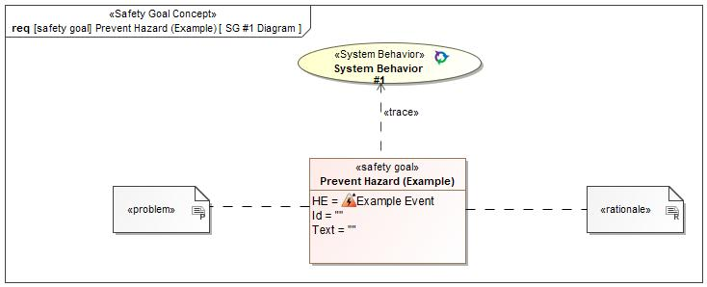

Figure 1: SG #1 Diagram – Prevent Hazard (Example)

*Note: The authoritative source for the Safety Goals is document “FFSD 02 Hazard Analysis* *and Risk Assessment”. The documentation of Safety Goals in this chapter (In the Argumentation for Safety Goal achievement) is for information purposes only.*

*The authoritative source for the Functional Safety Requirements is section 2.1.x.3: of this document. The documentation of Functional Safety Requirements in the following chapter (complete or summarised) is for information purposes only.*

#### Warning and Recovery Concept

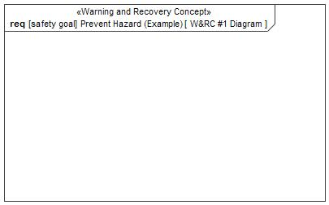

Figure 7: W&RC #1 Diagram – Prevent Hazard (Example)

#### FSRs for - Prevent Hazard (Example)

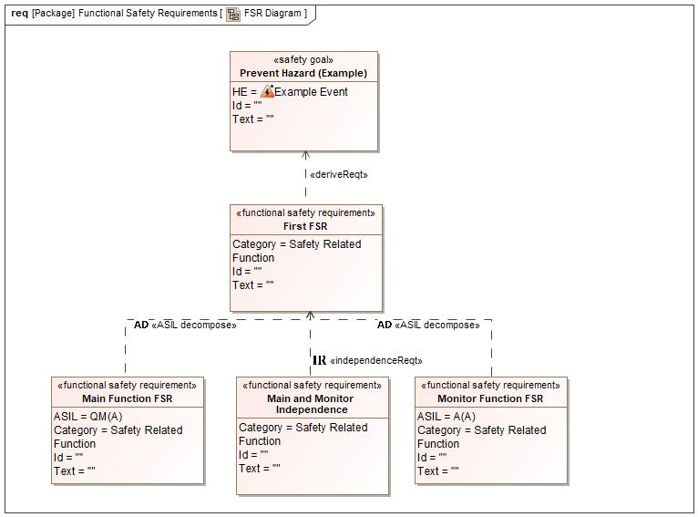

Figure 1. Prevent Hazard (Example)

First FSR

Related to:

* Safe States:
  + Safe State #1

|  |  |  |  |  |  |  |  |
| --- | --- | --- | --- | --- | --- | --- | --- |
| Requirement ID: | | | | | | | |
| **Purpose** |  | | | | | | |
| **V&V Acceptance Criteria** |  | | | | | | |
| **Notes** |  | | | | | | |
| **Source** |  | | | | | **Owner** |  |
| **Source Req.** | * -1553740733.jpg Prevent Hazard (Example) | | | | | **V&V Method** |  |
| **Type** | N/A | | **Priority** | | N/A | **Status** |  |
| **ASIL** |  | | **Category** | | Safety Related Function | **Fault Handling Time** | N/A |
| [Req. Template](http://wiki.ford.com/display/RequirementsEngineering/Requirements+Attributes) Version | | 6.0 | | End of Requirement | | | |

Main Function FSR

Related to:

* Safe States:
  + Safe State #1

|  |  |  |  |  |  |  |  |
| --- | --- | --- | --- | --- | --- | --- | --- |
| Requirement ID: | | | | | | | |
| **Purpose** |  | | | | | | |
| **V&V Acceptance Criteria** |  | | | | | | |
| **Notes** |  | | | | | | |
| **Source** |  | | | | | **Owner** |  |
| **Source Req.** | * -1553740733.jpg Prevent Hazard (Example) | | | | | **V&V Method** |  |
| **Type** | N/A | | **Priority** | | N/A | **Status** |  |
| **ASIL** | QM(A) | | **Category** | | Safety Related Function | **Fault Handling Time** | N/A |
| [Req. Template](http://wiki.ford.com/display/RequirementsEngineering/Requirements+Attributes) Version | | 6.0 | | End of Requirement | | | |

Main and Monitor Independence

Related to:

* Safe States:
  + Safe State #1

|  |  |  |  |  |  |  |  |
| --- | --- | --- | --- | --- | --- | --- | --- |
| Requirement ID: | | | | | | | |
| **Purpose** |  | | | | | | |
| **V&V Acceptance Criteria** |  | | | | | | |
| **Notes** |  | | | | | | |
| **Source** |  | | | | | **Owner** |  |
| **Source Req.** | * -1553740733.jpg Prevent Hazard (Example) | | | | | **V&V Method** |  |
| **Type** | N/A | | **Priority** | | N/A | **Status** |  |
| **ASIL** |  | | **Category** | | Safety Related Function | **Fault Handling Time** | N/A |
| [Req. Template](http://wiki.ford.com/display/RequirementsEngineering/Requirements+Attributes) Version | | 6.0 | | End of Requirement | | | |

Monitor Function FSR

Related to:

* Safe States:
  + Safe State #1

|  |  |  |  |  |  |  |  |
| --- | --- | --- | --- | --- | --- | --- | --- |
| Requirement ID: | | | | | | | |
| **Purpose** |  | | | | | | |
| **V&V Acceptance Criteria** |  | | | | | | |
| **Notes** |  | | | | | | |
| **Source** |  | | | | | **Owner** |  |
| **Source Req.** | * -1553740733.jpg Prevent Hazard (Example) | | | | | **V&V Method** |  |
| **Type** | N/A | | **Priority** | | N/A | **Status** |  |
| **ASIL** | A(A) | | **Category** | | Safety Related Function | **Fault Handling Time** | N/A |
| [Req. Template](http://wiki.ford.com/display/RequirementsEngineering/Requirements+Attributes) Version | | 6.0 | | End of Requirement | | | |

### Derivation of Functional Safety Requirements on Assumptions

**#Classification**: Functional Safety only

**#Hint:** Derive requirements from the Assumptions (refer to section “Safety Assumptions”

No Functional Safety Requirements tracing to Assumptions specified.

## ASIL Decomposition of Functional Safety Requirements

***#Classification:*** *Functional Safety Only*

***#Hint:*** *For ASIL D features additional measures like a requirements decomposition might be required. Fill out the following table for each ASIL D decomposition applied in the feature. The decomposition rationale is the reason why the decomposition was performed, whereas the rationale for each requirement expresses the reason and thought behind that particular requirement and should include how the requirement is able to independently fulfill the needs of the parent requirement.*

***#Link:***[*Functional Safety Sharepoint*](https://pd3.spt.ford.com/sites/GlobalFunctionalSafety/Pages/default.aspx) *- Functional Safety Concept*

### Decomposition of Functional Safety Requirement

| Initial Safety Requirement | First FSR | |
| --- | --- | --- |
| Decomposition Rationale |  | |
| Method for Decomposition | A -> A(A) + QM(A) | |
| Functional Safety Requirement 1 after Decomposition | F-S-Req-ID |  |
| F-S-Req. Title | Main Function FSR |
| ASIL | QM(A) |
| Rationale |  |
| Satisfied by |  |
| Functional Safety Requirement 2 after Decomposition | F-S-Req-ID |  |
| F-S-Req. Title | A(A) |
| ASIL | Monitor Function FSR |
| Rationale |  |
| Satisfied by |  |
| Functional Safety Requirement for Independence | F-S-Req.-ID |  |
| F-S-Req. Title | Main and Monitor Independence |
| ASIL |  |
| Rationale |  |

# Architecture

## Functional Architecture

**#Classification:** Mandatory for Functional Safety – otherwise optional

**#Hint**: This section depicts the coarse Functional Architecture. This architectural step is needed to find the right functional partitioning for the function level. The function shown here are those, which are specified on function level. Either SysML activity diagrams or Data Flow Diagrams could be used to depict such a Functional Architecture. For bigger features, which are decomposed in a hierarchical manner down to atomic functions (and which do not follow the Functional Safety process), a function tree could be given here.

**#Links:**

* Functional Decomposition: [RE Wiki – Functional Decomposition](http://wiki.ford.com/display/RequirementsEngineering/Functional+Decomposition)
* SysML - Activity Diagrams or [RE Wiki - Data Flow Diagrams](http://wiki.ford.com/display/RequirementsEngineering/Data+Flow+Diagram?src=contextnavpagetreemodehttp://wiki.ford.com/display/RequirementsEngineering/Data+Flow+Diagram?src=contextnavpagetreemode)
* Data Flow Diagram: [RE Wiki – Data Flow Diagram](http://wiki.ford.com/display/RequirementsEngineering/Functional+Decomposition)

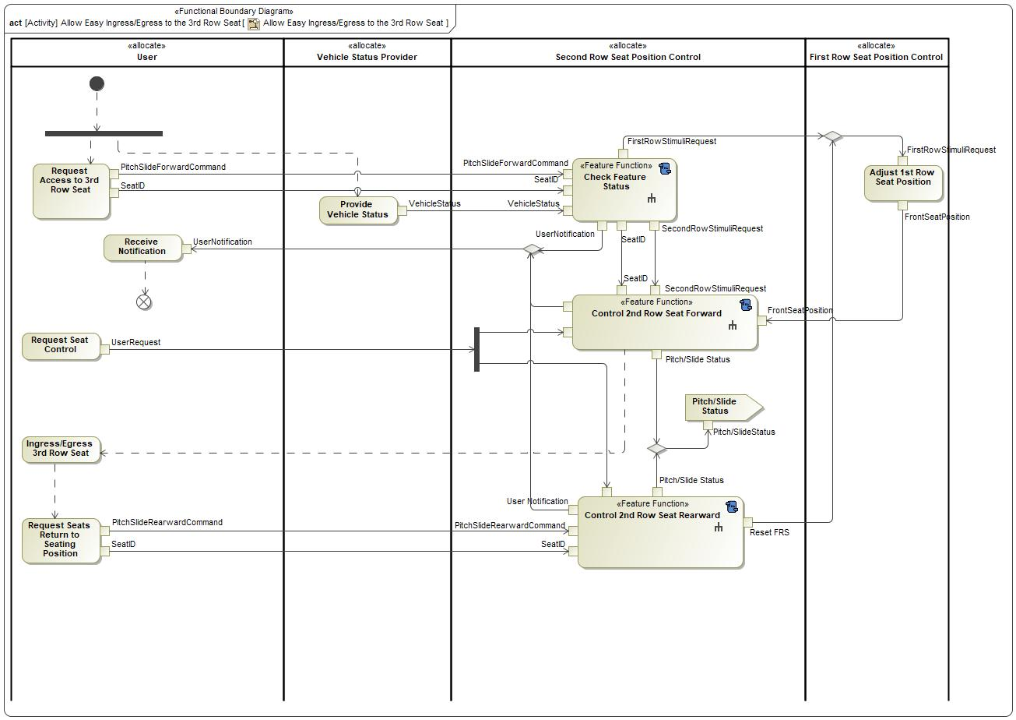

Figure 8: Allow Easy Ingress/Egress to the 3rd Row Seat

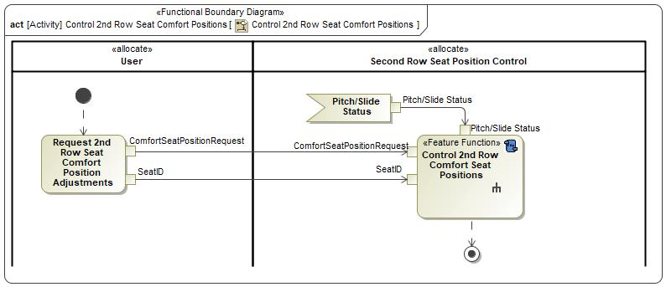

Figure 8: Control 2nd Row Seat Comfort Positions

### List of Functions

**#Hint:** The functions shown in the Functional Architecture should be listed and described in the table below

| **Function Name** | Description | Comments |
| --- | --- | --- |
| *(activity)* Request Seat Control |  |  |
| *(action)* Adjust 1st Row Seat Position  *(activity)* Adjust 1st Row Seat Position | *(action)* When the FRS is given permission to begin moving forward so that the SRS may pitch forward, it will send the SRS its position so that the SRS will know that the FRS is out of the way for the SRS to begin pitching/sliding forward. |  |
| *(action)* Check Feature Status  *(activity)* Check Feature Status | *(action)* This will check the status of the vehicle to confirm that it is able to begin the PPSEEE Pitch/Slide Process.  *(activity)* This will check the status of the vehicle to confirm that it is able to begin the PPSEEE Pitch/Slide Process. |  |
| *(action)* Control 2nd Row Seat Rearward  *(activity)* Control 2nd Row Seat Rearward | *(action)* When the SRS is requested to pitch rearward, this will control the rearward movement of the requested SRS PPSEEE Return Process.  *(activity)* When the SRS is requested to pitch rearward, this will contain the rearward movement of the requested SRS (PPSEEE Return Process). |  |
| *(action)* Ingress/Egress 3rd Row Seat  *(activity)* Ingress/Egress 3rd Row Seat | *(action)* This is the User entering/exiting the TRS. |  |
| *(action)* Provide Vehicle Status  *(activity)* Provide Vehicle Status | *(action)* This provides the status of the vehicle for which the PPSEEE Pitch/Slide Process can function. |  |
| *(action)* Receive Notification  *(activity)* Receive Notification | *(action)* User will be notified if the PPSEEE Pitch/Slide Process or the PPSEEE Return Process has been terminated for any reason or if the conditions aren't correct to begin the PPSEEE Pitch/Slide Process. |  |
| *(action)* Request Access to 3rd Row Seat  *(activity)* Request Access to 3rd Row Seat | *(action)* This represents the User selecting the SRS to be pitched forward for easy ingress/egress to the TRS via the PPSEEE Pitch/Slide Process. |  |
| *(action)* Request Seats Return to Seating Position  *(activity)* Request Seats Return to Seating Position | *(action)* This represents the User selecting the SRS to be pitched rearward in order to reseat the seat via the PPSEEE Return Process. |  |
| *(action)* ​Control 2nd Row Seat Forward  *(activity)* ​Control 2nd Row Seat Forward | *(action)* When the SRS is requested to pitch forward and the conditions are met, this will control the forward movement of the requested SRS (PPSEEE Pitch/Slide Process).  *(activity)* When the SRS is requested to pitch forward and the conditions are met, this will contain the forward movement of the requested SRS (PPSEEE Pitch/Slide Process). |  |

Table 17: List of Functions on Allow Easy Ingress/Egress to the 3rd Row Seat

| **Function Name** | Description | Comments |
| --- | --- | --- |
| *(action)* Control 2nd Row Comfort Seat Positions  *(activity)* Control 2nd Row Comfort Seat Positions | *(activity)* This is to provide the User to be able to adjust the comfort seats of the requested SRS. |  |
| *(action)* Request 2nd Row Seat Comfort Position Adjustments  *(activity)* Request 2nd Row Seat Comfort Position Adjustments |  |  |

Table 17: List of Functions on Control 2nd Row Seat Comfort Positions

## Logical Architecture

**#Classification:** Functional Safety Analysis only

**#Hint:** FS Analysis requires a description of the boundary of the feature and its elements. A simple block diagram or a SysML Internal Block Diagram could be used to depict the Logical Architecture

***#Link:*** [*Ford Functional Safety Sharepoint*](https://pd3.spt.ford.com/sites/GlobalFunctionalSafety/Pages/default.aspx)

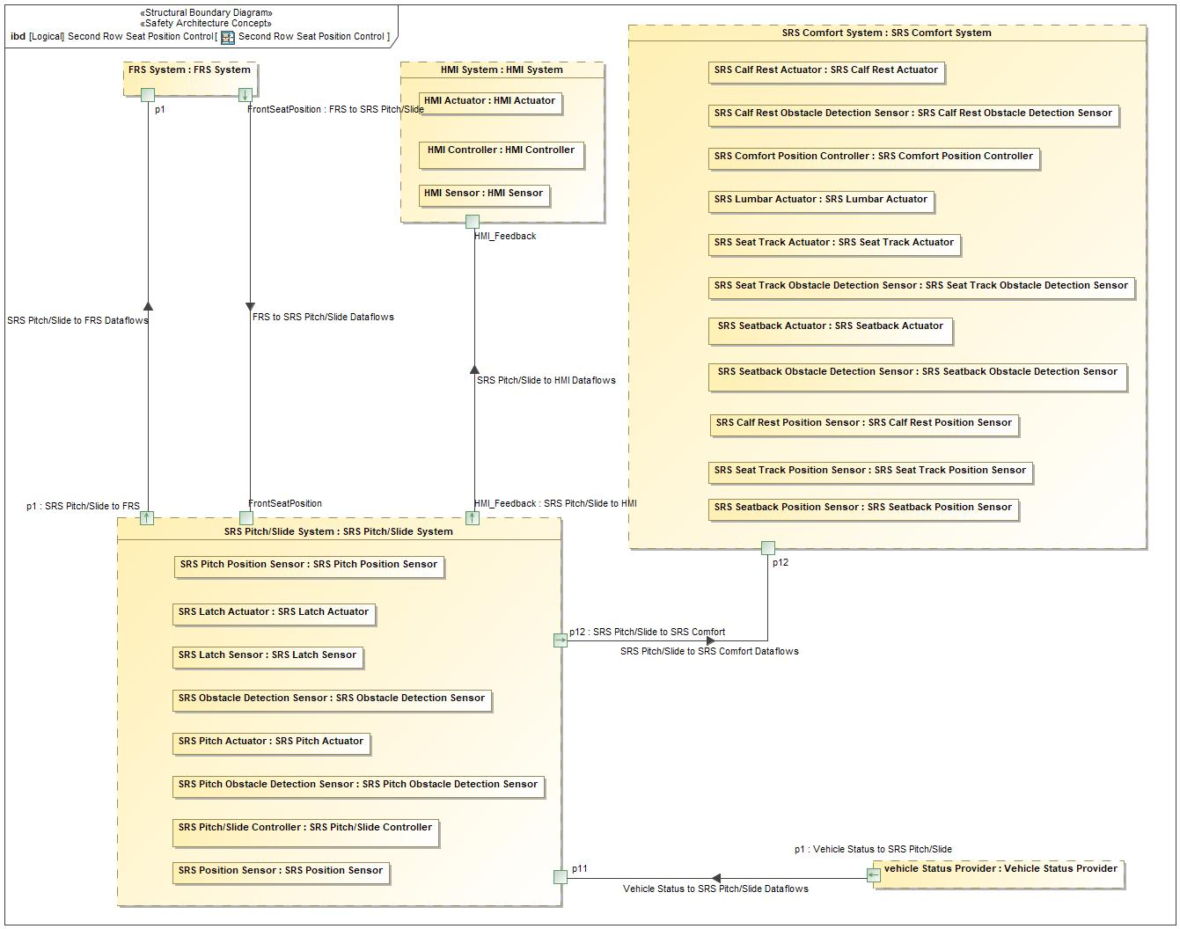

Figure 9: Second Row Seat Position Control

### Logical Elements

**#Hint:** Lists the elements of the Logical Architecture and the functions from the Functional Architecture, which are allocated to those elements.

|  |  |  |  |
| --- | --- | --- | --- |
| **Element Name** | **Description** | **Allocated Functions** | **Comments** |
| FRS System | This represents the FRS System. |  |  |
| HMI Actuator |  |  |  |
| HMI Controller |  |  |  |
| HMI Sensor |  |  |  |
| HMI System | This represents the HMI System. |  |  |
| SRS Calf Rest Actuator | This will provide the actuation of the calf rest comfort setting. |  |  |
| SRS Calf Rest Obstacle Detection Sensor | This will provide the sensing of obstacle detection of the SRS Calf Rest. |  |  |
| SRS Calf Rest Position Sensor | This will provide the position of the SRS Calf Rest. |  |  |
| SRS Comfort Position Controller | This will control the functionality of the seat comfort sensors and actuators. |  |  |
| SRS Comfort System | This represents the SRS Comfort System. |  |  |
| SRS Latch Actuator | This will provide the actuation of the SRS Latches during the PPSEEE Pitch/Slide Process and PPSEEE Return Process. |  |  |
| SRS Latch Sensor | This will provide the positon of the SRS Latches during the PPSEEE Pitch/Slide Process and PPSEEE Return Process. |  |  |
| SRS Lumbar Actuator | This will provide the actuation of the lumbar comfort setting. |  |  |
| SRS Obstacle Detection Sensor | This will provide the sensing of obstacle detection of the SRS. |  |  |
| SRS Pitch Actuator | This will provide the actuation of the SRS Pitch during the PPSEEE Pitch/Slide Process and PPSEEE Return Process. |  |  |
| SRS Pitch Obstacle Detection Sensor |  |  |  |
| SRS Pitch Position Sensor |  |  |  |
| SRS Pitch/Slide Controller | This will control the functionality of the SRS PPSEEE Pitch/Slide Process and PPSEEE Return Process. |  |  |
| SRS Pitch/Slide System | This represents the SRS Pitch/Slide System. |  |  |
| SRS Position Sensor | This provides the position of the SRS during the PPSEEE Pitch/Slide Process and PPSEEE Return Process. |  |  |
| SRS Seat Track Actuator | This will provide the actuation of the fore/aft comfort setting. |  |  |
| SRS Seat Track Obstacle Detection Sensor | This will provide the sensing of obstacle detection of the SRS Lumbar. |  |  |
| SRS Seat Track Position Sensor | This will provide the position of the SRS Seat in relation to the Fore/Aft position. |  |  |
| SRS Seatback Actuator | This will provide the actuation of the incline/recline comfort setting. |  |  |
| SRS Seatback Obstacle Detection Sensor | This will provide the sensing of obstacle detection of the SRS seatback. |  |  |
| SRS Seatback Position Sensor | This will provide the position of the SRS Seatback. |  |  |
| Vehicle Status Provider | This represents the Vehicle Status Provider. |  |  |

Table 19: Logical Elements

### Logical Interfaces

**#Hint:** Describe the interactions of the feature with other features or elements.

|  |  |  |  |
| --- | --- | --- | --- |
| **Interface** | **Direction** | **Description** | **Value Range** |
| FRS to SRS Pitch/Slide Dataflows | FrontSeatPosition (FRS System) To FrontSeatPosition (SRS Pitch/Slide System) |  |  |
| SRS Pitch/Slide to FRS Dataflows | p1 (SRS Pitch/Slide System) To p1 (FRS System) |  |  |
| SRS Pitch/Slide to HMI Dataflows | HMI_Feedback (SRS Pitch/Slide System) To HMI_Feedback (HMI System) |  |  |
| SRS Pitch/Slide to SRS Comfort Dataflows | p12 (SRS Pitch/Slide System) To p12 (SRS Comfort System) |  |  |
| Vehicle Status to SRS Pitch/Slide Dataflows | p1 (Vehicle Status Provider) To p11 (SRS Pitch/Slide System) |  |  |

Table 18: Feature Interactions

# Open Concerns

**#Hint:** The following list presents open concerns, which have to be discussed or clarified over the course of the on-going requirements engineering.

| ID | Concern Description | e-Tracker / Reference | Responsible | Status | Solution |
| --- | --- | --- | --- | --- | --- |
| 1 |  |  |  |  |  |

Table 20: Open Concerns *(Not supported by MagicDraw report generation)*

# Revision History

**#Hint:** A new version number is assigned to a document with a given revision each time it is checked in to Team Center (TCSE). After release of a revision, the document cannot be edited and no new versions can be created on that revision. When updating the document after that, a new revision has to be created and new versions on that revision will be created upon checking in.

Revision 1.

## Template Revisions

*#Important: Do not change this section*

|  |  |  |  |  |
| --- | --- | --- | --- | --- |
| Version | Rev. | Date | Description | Responsible |
| *0* | *6* | *2015-05-26* | * *Chapter “Feature Overview” and made a 2nd level heading.* * *Chapter “Feature Modeling” divided into 3 subchapter (“Scenarios”, “Use Cases”, “State Machines”) for different modeling methods* | *Jbaden1* |
| *0* | *7* | *2015-05-27* | * *Table of Content updated* * *Template Revision History chapter added* | *Jbaden1* |
| *0* | *8* | *2015-07-02* | * *Section “Unsettled Issues” added* | *Alevin7* |
| *0* | *9* | *2015-08-04* | * *Section “Feature Variants” added* * *Section “Feature Boundary Diagram” renamed to “Feature Context Diagram”* * *Document Properties adapted to match needs of VBA macros* | *Jbaden1, Awegman1* |
| *1* | *0* | *2015-09-11* | * *Section “Feature Variants” reworked* * *Feature Goals removed. Only “Safety Goals“ chapter remains.* * *Heading 2 formatting issues corrected.* * *Requirements / Use Cases Listing removed from traceability chapter.* * *Formatting of attribute table in Notation chapter corrected* * *Open Topics / Known Issues chapter moved to the end* | *Jbaden1* |
| *1* | *1* | *2015-11-16* | * *Table-Styles removed (for smooth VSEM import)* * *Some clean-up of sections “Purpose” and “Audience”* | *Awegman1, jbaden1* |
| *1* | *2* | *2016-02-26* | * *Minor corrections based on lessons learned from CC and PCL pilot (e.g. section market/regions) and discussion with Functional Safety Team (purpose of feature)* * *Footer corrected* * *Boundary diagram interface chapter renamed to influences.* | *Jbaden1* |
| *1* | *3* | *2016-02-26* | * *Minor corrections after review with Whitney Keith from Functional Safety team* | *Jbaden1* |
| *1* | *4* | *2016-03-10* | * *Some cleanup of meta-data in Word Properties* | *Jbaden1* |
| *1* | *5* | *2016-03-10* | * *Footer formatting corrected (Issue 19)* * *Results from review with Functional Safety Team incorporated (Issue 20).* | *jbaden1* |
| *1* | *6* | *2016-04-18* | * *Scenario Template added* | *Jbaden1* |
| *1* | *7* | *2016-04-18* | * *Chapter “Operation Modes and States” moved before “Use Case” section.* | *Jbaden1* |
| *1* | *8* | *2016-04-18* | * *Broken Wiki links repaired.* | *Jbaden1* |
| *2* | *0* | *2016-05-19* | * *Adapted to Specification_Macros.dotm V2.0* * *Requirements Templates chapter (ch. 1.7.1) no longer has an attribute table, but refers directly to the Wiki..* | *Jbaden1* |
| *2* | *1* | *2016-06-10* | * *Table for Context Diagram modified (lists external entities and Influence Description only)* | *Jbaden1* |
| *2* | *2* | *2016-07-08* | * *Template version added to footer* * *Several hints added to the various sections* * *Findings from Functional Safety Team incorporated.* * *RE_SafetyRequirement style added* | *Jbaden1* |
| *2* | *3* | *2016-09-21* | * *Update from Functional Safety Team incorporated (“Lessons Learned”, “System Behaviors for HARA”)* | *Jbaden1* |
| *2* | *4* | *2016-11-15* | * *Update from Functional Safety Team incorporated (“Lessons Learned”, “System Behaviors for HARA”)* * *Explanatory notes made more formal* | *Jbaden1* |
| *3* |  |  | *Skipped to synchronize with Specification_Macros.dotm* |  |
| *4* |  |
| *5* | *0* | *2017-01-13* | * *Meta data updated for specification macros, version 3.1* * *SW Unit chapter removed for the time being* * *Green boxes added for user hints* | *Jbaden1* |
| *5* | *1* | *2017-01-18* | * *Minor editorial changes* | *Jbaden1* |
| *6* | *0* | *2017-02-03* | * *CR48: Chapter 6 renamed from “Safety” to “Functional Safety”. New sub-chapter “Safety” introduced in Non-Functional Requirements section* | *Jbaden1* |
| *6* | *0* | *2017-04-28* | * *CR7: “RequirementsTraceability” chapter removed* | *Jbaden1* |
| *6* | *0* | *2017-11-15* | * *CR32/53: New Cover Sheet + Disclaimer replaces FAP-150 like ones.* * *CR75: Some rewording -> Terminology to Glossary, Notation -> Document Conventions* * *CR49: Rename “Assumptions & Constraints” to “Assumptions”* * *CR74: Safety Assumptions added to chapter 6.* * *CR58: Add function allocation column to Logical Architecture chapter* | *Jbaden1* |
| *6* | *0* | *2018-01-31* | * *CR63: Updated links to Functional Safety Sharepoint* | *Jbaden1* |
| *6* | *0* | *2018-07-24* | * *CR69: Add FSR to FeatureDoc* * *CR64: Add new section "Design Requirements" to Function Spec and Feature Spec* | *Jbaden1* |
| *6* | *0* | *2018-08-06* | * *CR53: some corrections for metada and formatting* | *Jbaden1* |
| *6* | *0* | *2018-09-28* | * *Broken links to RE Wiki repaired* | *Jbaden1* |
| *6* | *0* | *2018-10-31* | * *Cover sheet and footer more GIS like. Functional Safety team feedback incorporated:*   + *New subsections “Functional Safety Requirements, (Decomposed) FSRs and Parameters / Values*   + *Removal of “Logical Architecture”* | *Jbaden1* |
| *6* | *0* | *2018-12-12* | * *FSR template removed, now as a macro in the Specification_Macros.dotm* | *Jbaden1* |
| *N* |  | *2019-04-03* | * *Updated code for context diagrams, actors and use cases.* * *Updated code structure with all macros at the beginning.* * *Updated code to populate assumptions using element-assumption relationship or hazardous event.* | *snuesch* |
| *N* |  | *2019-04-18* | * *Added structural boundary diagram for FuSa based on TGB discussion.* * *Added operating modes to functional safety requirements.* | *snuesch* |
| *N* |  | *2019-04-25* | * *Improved export of actions and activities on functional boundary diagram.* | *snuesch* |
| *6* | *0b* | *2019-05-23* | * *Re-introduce “Logical Architecture” (for Functional Safety)* | *Jbaden1* |
| *N* |  | *2019-06-17* | * *Aligned “Architecture” section with RE template.* * *Made “Ford Documents” table more flexible.* * *Added template terms to glossary* | *snuesch* |
| *N* |  | *2019-06-25* | * *Improved use cases to handle Primary and Secondary actors.* * *Added Performance Requirements to Uncategorized.* | *snuesch* |
| *6* | *0b* | *2019-06-26* | * *Chapter “Logical Elements” in “Logical Architecture” section added (FuSa CR 15136240)* * *“References” and “Glossary” chapter moved from section “Feature Overview” to “Introduction”. References and Glossary should be available in the document as early as possible* | *Jbaden1* |
| *N* |  | *2019-07-25* | * *Added populated “Logical Elements” table and allocated functions.* * *Export documentation field of context diagram.* | *snuesch* |
| *N* |  | *2019-08-09* | * *Export documentation field of use case diagram.* * *Fixed bug in Feature Requirement Verification Method.* * *Simplified export of References without publisher.* | *snuesch* |
| *N* |  | *2019-08-21* | * *Improved glossary and acronym tables* | *snuesch* |
| *N* |  | *2019-08-28* | * *Fixed bug in populating title in header* | *snuesch* |
| *N* |  | *2019-09-16* | * *Updated bibliography export* | *snuesch* |
| *N* |  | *2019-09-27* | * *Updated export of Verification Method and Requirement Status for Feature Requirements and V&V Method for Functional Safety Requirements.* | *snuesch* |
| *O* |  | *2019-11-12* | * *Updated bibliography export to include URL.* * *Allow hardware element on context diagram.* * *labelTag variable can be used to filter revision history.* * *Added logical property element type to beplled in from structural boundary diagram.* | *snuesch* |

# Appendix

## Definitions

| **Definition** | **Description** |
| --- | --- |
| "Enabled" Position | For the 1st Row Seat, it is the target position for the 1st row seat to enable the pitch/slide action of the 2nd row seat to be able to complete.  For the 2nd Row Seat, it is the target position for the 2nd row seat to be able to start the pitch/slide action. |
| "Initial" Position | The position that each seat starts in before the Power Pitch/Slide is requested.  Also, the position to which the 1st row seat shall return when the Power Pitch/Slide Return is commanded. |
| "Reset" Position | The position to which the 2nd row seat should return when the Power Pitch/Slide return is commanded. |
| Fore/Aft Move Timing | The time (in mm/s) that the SRS moves the seat Fore/Aft comfort settings due to user request. |
| Lumbar Move Timing | The time (in mm/s) that the SRS moves the seat Lumbar comfort settings due to user request. |
| Obstacle | In relation to "Obstacle Detection', an Obstacle blocks the motor from movement and is detected through a spike in motor current. |
| PPSEEE Pitch/Slide Process | The sequence of events where the 1st and 2nd row seats move to allow easy access to the 3rd row. |
| PPSEEE Return Process | The sequence of events following a 3rd row ingress/egress where the 1st and 2nd row seats reset themselves to post ingress/egress. |

Table 21: Definitions used in this document

## Abbreviations

| **Abbr.** | **Stands for** |
| --- | --- |
| FRS | First Row Seat |
| PPSEEE | Power Pitch Slide Easy Entry/Exit |
| SRS | Second Row Seat |
| TRS | Third Row Seat |

Table 22: Abbreviations used in this document

Document ends here.